How to View/Retrieve E-mail Internet Headers - Outlook 2003
Right-click on the message in the folder view, then choose Options.
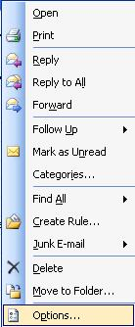
This will bring up the Properties dialog with the Internet headers located at the bottom:
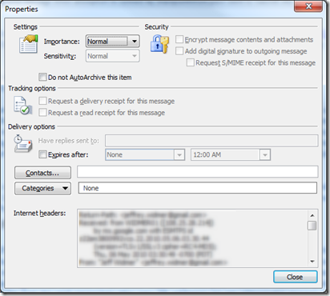

How to View/Retrieve E-mail Internet Headers - Outlook 2007
Open the e-mail message in its own window (by double-clicking on the message).
Go to Options > Info for the message:

Message Options > Internet headers:

How to View/Retrieve E-mail Internet Headers - Outlook 2010
Open the e-mail message in its own window (by double-clicking on the message).
Go to File > Info for the message:
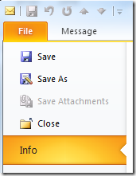
In the right-hand pane, click on the Properties button.
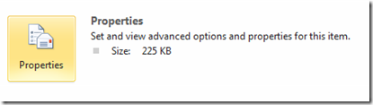
This will bring up the Properties dialog with the Internet headers located at the bottom:

